**RAILWAY MANAGEMENT SYSTEM**

Step 1

Download the Railway Management System.

Unzip the file Railway Management File, it has the database file and all the systems files.

Step 2

Open the Railway Management System solution file dubbed and RailwayManagementSystem.sln

Using visual studio software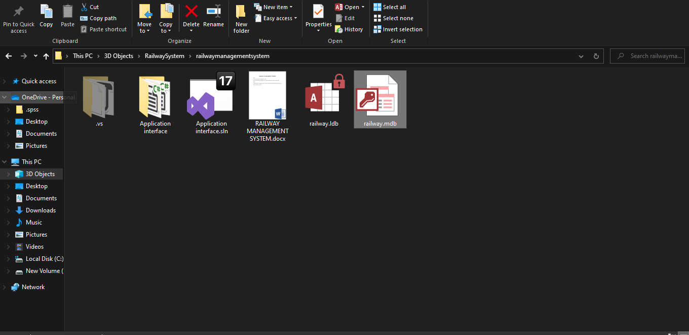

Open the project and load the railway.mdb database file using the connect to database feature in the top left corner.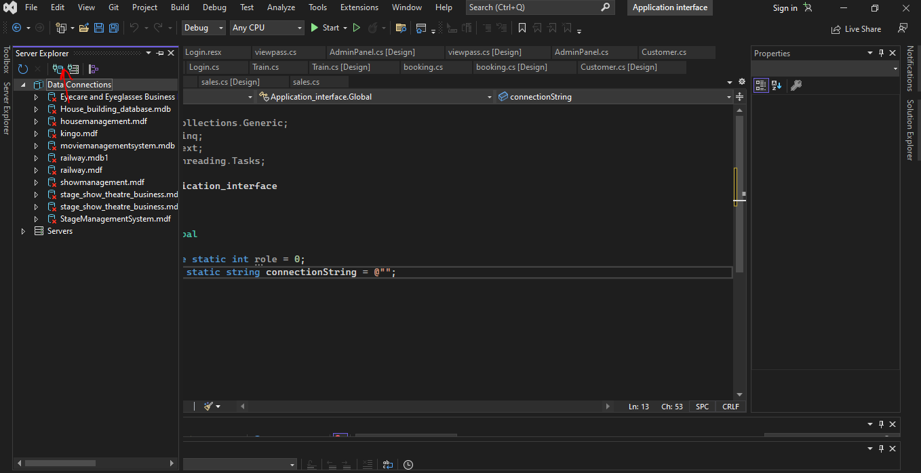

Connect to the database, test the connection to see if the connection is good.

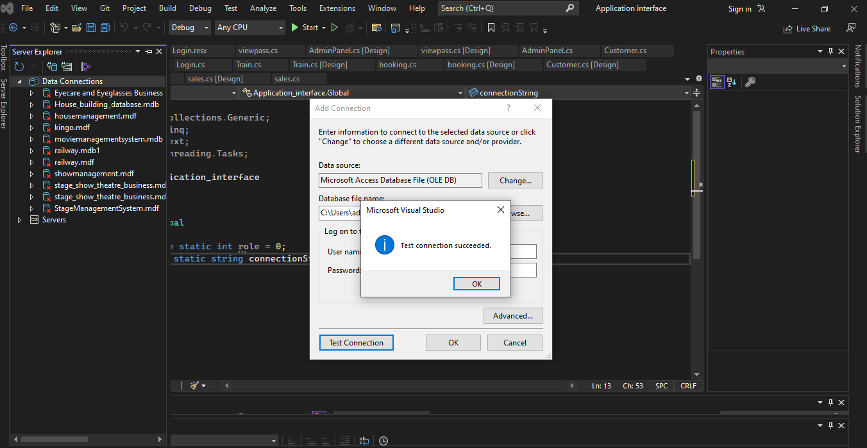

Right click on the database and go to properties to get the connection string to use in connecting to the database.

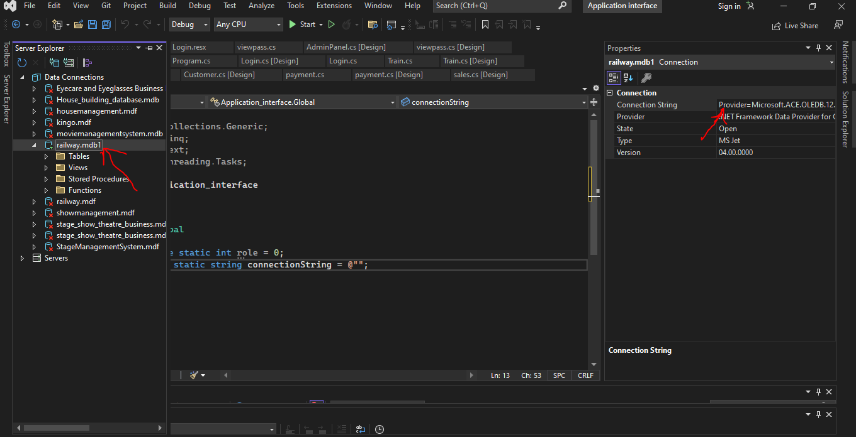

Create a Global.cs class, in this class you will copy the connection string to make a database connection to all of the application.

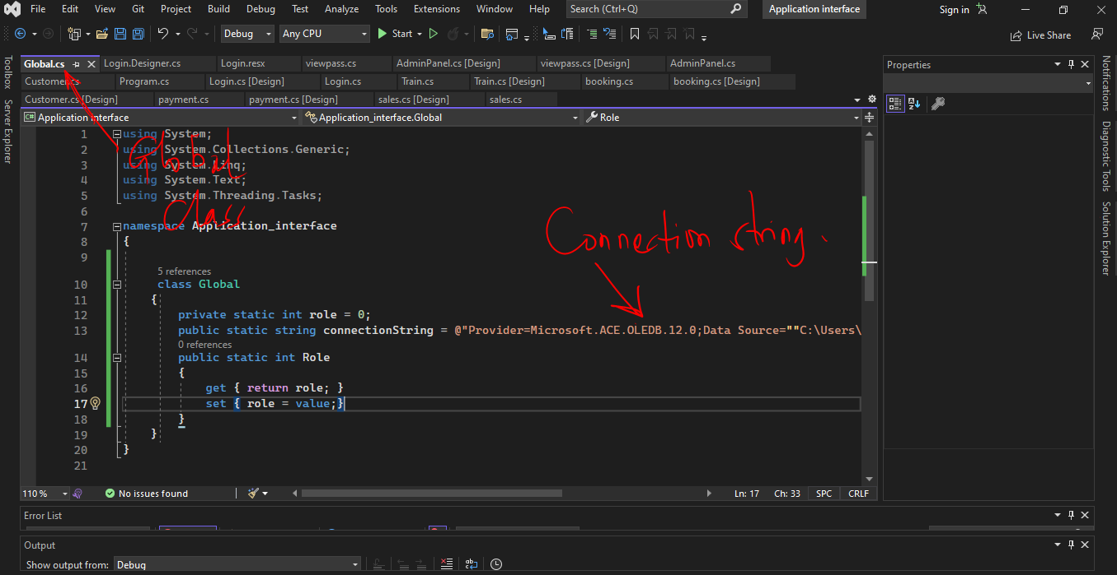

N/B Always load the database file into the system then copy the string to the global.cs, place within the quotes, so that there is a connection and less problems with submitting data to the database.

Then login into the application.

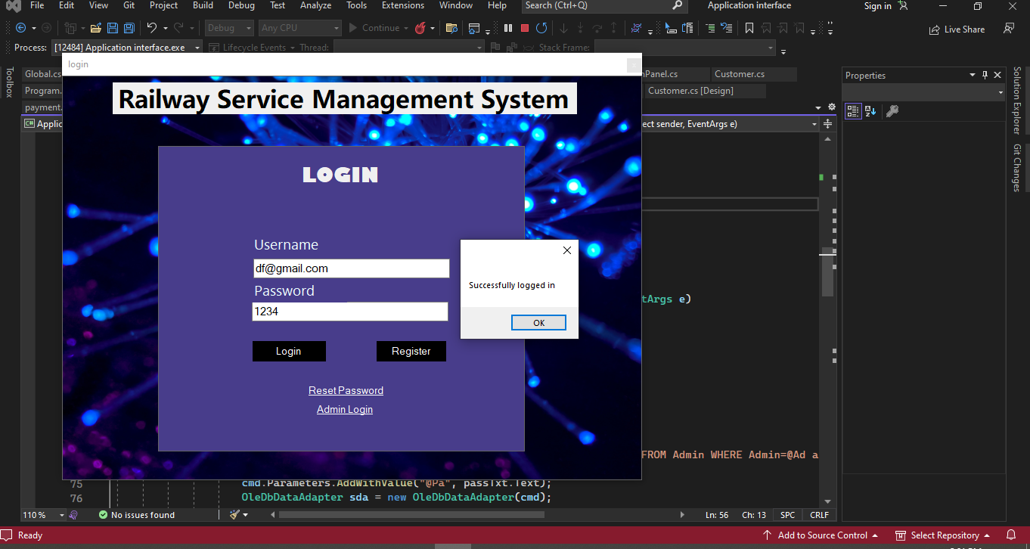

Then Enjoy your booking experience.